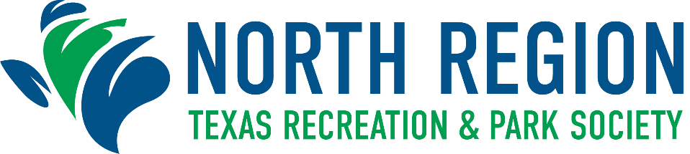

Regional Awards Program Nomination Form
Deadline for Submission: Friday, September 3, 2021

COMMUNICATIONS AWARD
The purpose of this award is to recognize outstanding communication efforts of a park and
recreation or leisure agency for the past year through the use of social media.

Class Population

Class I Cities 75,000 and over
Class II Cities up to 75,000

City Population: Class: ☐ - I Class: ☐ - II

Name of Nominating City:

Agency:

Address: City: Zip:

Nominator: Title:

Phone: Email:

As evidence of achievement, nominations for the Communications Award must include the following information:

- Overview of communication efforts for the event, program or agency issue.

- Evidence of the effectiveness of communication efforts to your target market through the use of facebook, twitter or other social media.

- You may submit 2-5 examples of your communication efforts in action (at an event, etc).

**Submission requirements can be found on the Program Nomination Information Form.

Insert your 4-5 line summary here:

Insert your written narrative (no more than 3 pages) here:

All winners will be notified by October 1, 2021

