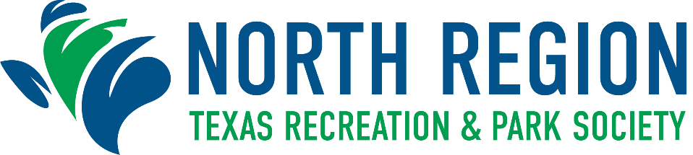

Regional Awards Program Nomination Form
Deadline for Submission: Friday, September 2, 2022

EXCELLENCE IN MAINTENANCE AWARD
The purpose of this award is to recognize superior maintenance standards and
practices including creative approaches to problem solving and innovative means
and methods of maintaining parks and recreation facilities.

Class Population

Class I Cities 75,000 and over
Class II Cities up to 75,000

City Population: Class: ☐ - I Class: ☐ - II

Name of Nominee:
Agency:
Address: |  |  |  |  |  |  |  | City: |  |  |  | Zip:
Nominator: |  |  |  |  |  |  |  |  | Title:
Phone: |  |  |  |  |  | Email:

Nominations for the Maintenance Award must include all of the following information for creativity or innovation in the maintenance of parks or recreation facilities:

- Detailed description of the maintenance problem and solution;

- Evidence of originality, innovation, and adaptability in the solution;

- Evidence of solid cost recovery or reduction in labor forces or material resources;

- Evidence that solution allows maintenance to proceed more efficiently and effectively.

**Submission requirements can be found on the Program Nomination Information Form.

Insert your 4-5 line summary here:

Insert your written narrative (no more than 3 pages) here:

All winners will be notified by October 7, 2022

