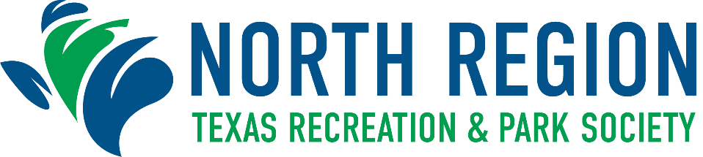

Regional Awards Program Nomination Form
Deadline for Submission: Friday, September 2, 2022

PROMOTIONAL AWARD
The purpose of this award is to recognize outstanding promotional efforts of a park and
recreation or leisure agency for the past year. This award should represent an individual event.

Class Population

Class I Cities 75,000 and over
Class II Cities up to 75,000

City Population: Class: ☐ - I Class: ☐ - II

Name of Nominating City:

Agency:

Address: City: Zip:

Nominator: Title:

Phone: Email:

As evidence of achievement, nominations for the Promotional Award must include the following information:

- Overview of Public Affairs/Marketing Office

- Evidence of the effectiveness of promotional programs to your target market

- You may submit 2-5 pictures of your promotional efforts in action (at an event, etc).

- Electronic versions of the following materials (submit in PDF format):
  - Printed Booklets (2 - 4 newsletters, program brochures, or annual reports)
  - Single page printed materials (2 - 4 posters, flyers, cards, or post cards)
  - News articles (2 - 4 news releases, photos, or feature articles)
  - Novelty items (2 - 4 T-shirts, balloons, or key rings)
  - Videos (link to YouTube video)

**Submission requirements can be found on the Program Nomination Information Form.

Insert your 4-5 line summary here:

Insert your written narrative (no more than 3 pages) here:

All winners will be notified by October 7, 2022

